English 150
Creating a Meme

Summer 2016
Date Due:

You will create an Internet meme based upon what you have learned about Iowa State University thus far in this course. This project will help prepare you for Assignment #5, in which you will be repurposing the content of one of your papers for a brochure or poster. In other words, this assignment is a sort of primer for working in the visual and electronic communication modes.

Your meme does not need to be hilarious or even very creative. However, it should demonstrate your ability to reflect on a place, organization, or artifact and create a simple visual message about it. Remember that many memes are not just for fun, and your meme may be more informative or thought provoking than funny. This assignment is more about matching text and images in an appealing and informative way than it is about being witty or clever.

How to create a meme
Begin by selecting a picture of your place, artifact, or organization. You should have something to say about this picture beyond a mere summary of the image. Brainstorm some ideas with your peers, see what works well, and try a few of them out. It’s hard to go completely wrong as long as you have a workable image and can recall the research you’ve done on the subject.

Next, compose the phrase you want to include with the image. You will want to superimpose the text on the image, meaning you will want to use a text tool to type your phrase onto the picture itself. Adobe Photoshop is an excellent software tool for this, but you can use Microsoft Paint or Image Viewer, Apple’s Preview or iPhoto, or open-source software like GIMP. See the instructions below for some tips on making your meme look more like a legitimate Internet meme.

Font and placement
Most Internet memes use white Impact font, and somewhere between 24 and 32 pt. is the ideal size. You may want to include a dark border around your text, though this is optional.

Many Internet memes follow the bumper sticker format of using an initial, standard, declarative phrase that most people can agree with or would expect, and then subverting that phrase with a message that undermines it. In rhetorical terms, this is the rhetorical device called anesis.

Examples

Memes abound on the Internet, and even if you were unfamiliar with the concept or term before this class, you have likely seen a meme before. Here is a classic example from Internet culture:

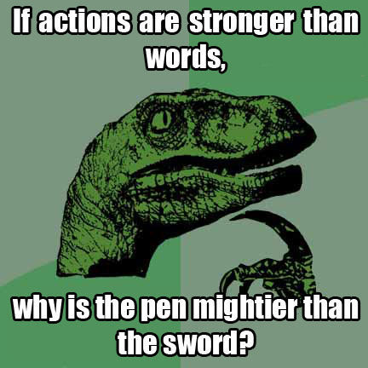

As an example of what I have in mind for this project, here is a meme that an English instructor created in under two minutes:

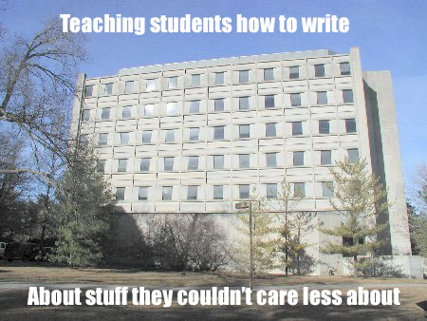

Evaluation Criteria
Since this project is worth only two points, it will be graded based upon whether you merely attempted to do the assignment or whether you really have put forth a good effort toward creating a meme. If you use an easy, online meme creator like imgur or memecreator, you will lose one point. To earn the full two points, your meme should meet most of these criteria:

Context
- Because memes rely on some inside humor or background knowledge, you don’t need to explain the context of the image fully. However, it should be relatively easy to guess the subject matter even if the viewer is unfamiliar with your topic.

Substance
- The super-imposed text should not just be a caption but rather an insightful phrase regarding the subject matter.
- The text combined with the image should create some sort of “Oh, I get it” moment for the audience.

Organization
- The super-imposed text should have a clear purpose and relation to the image.
- If you use two phrases, they should be clearly separated.

Style
- The text should be in a clear, legible font.
- There should be few if any spelling or word-choice errors.

Delivery
- Text placement and image choice should be aesthetically pleasing.
- The meme should be “readable,” that is, quickly discernible.

